Information Technology Architectures – IT401
Consultant's Analysis report
Cyrus Wiesner
7/14/17

Contents
Project Outline 3
Architecture selection 4
Project Timeline 9
Security 10
Primary security risks and threats 10
Impacts on business 11
Final analysis and recommendation 13
References 14

Employee Management System

Project Outline

ABC Limited is an engineering company dealing with manufacture of automotive. The company has got many employees located in different regions in the world. The company operates in the global market and it becomes difficult for the managers to manage their employees .Development of employee management system in the company will help the managers to effectively manage their employees. System management in the company determines the way the internal and external stakeholders in the company access and use information. While it becomes very difficult for employees to share and access information, Employee management system will help to interact and communicate. Our project will be based on the creation of access to useful information to all employees in the company. In the course of implementing this project, the organization will purchase and install the hardware and software requirements for the project. Our employees will be allowed to have points of access to the application within their workplaces through a role-based system (Kerzner, 2013). Only the designated managers will have to right to modify data, information, and documents. To protect the company information, the access to information will be limited to what the stakeholders in the application will be limited to what the users need. In this light, the internal operations will be accessed by the managers and employees with designated access while the suppliers will view the supply chain data for effective management (Klastorin et al. 2013).System Requirement

The project will involve the system engineering team who will determine the specific technology requirements for the completion of the project. They will evaluate the training requirements and the capacity of existing resources to bring the existing team on board with the application. After acquiring and installing the hardware and software elements of the project, they will allow the employees, customers, and suppliers to use the system for data and information (Kerzner, 2013). An evaluation process will be initiated to test the effectiveness of the team in using the project to improve the access and management of information. Since Employee access system allows the use of internet access, the external stakeholders will be allowed to maintain remote access to the details of their dealings with our company.
Employee management system project will increase the application of technology in improving the efficiency of operations in the company. With the ease of access to information, the employees will deliver their duties based on the progress and goals of the firm. As the officials introduce technology into the daily responsibilities of the company, they will be preparing employees for the future changes in engineering. Companies have to adopt the changes that cover their interests and motivate productivity and cost management (Tasevska et al.2014). Another objective of the company is to train the employees in the way systems affect engineers and the influence in their day to day duties. The information sharing system will allow the company to store information through documents and numbers in an organized manner. The members of the organization and the external stakeholders will have timely access to the progress made in all the projects. Extended coverage of the Employee management system is intended to centralize the information sharing system in our organization.

Architecture selection

Employee management system is a website that will be connected to the company database. The website will contain all employee information that stored in a centralized database. The system will make use of the client –server architecture. Servers, in this case, will be powerful computers and application in the company that will be used to store files and manages all the activities in the enterprise. The servers will be stored in a centralized location and will be accessed remotely by all the employees of the enterprise. Clients, in this case, will be employee’s personal computers and workstation that will relay on the server for information (Badgujar, et al.2015). In this process we takes three different types of architectures for your system like client server’s architecture, event driven’s architecture & layered architecture. Difference between these three architecture is determines as in client server’s architecture, each computer works as a client as well as a server while in event driven’s architecture which is software architecture used for describes production, consumption, detection & reaction for various types of events while layered architecture determines the combination of various types of layer. Out of these three architectures, client server’s architecture is best architecture for making any project in an effective manner. In client server architecture, each computer works as a client as well as a server. In this concept, we also describe the term cloud comes under hardware architecture. Cloud architecture consists various types of components and two main parts named front & back ends. Both terms are very important. Front ends determine as a part of client used for programming. Back ends determine as clouds itself. Distributed architecture is an architecture where services provided by one server to various clients shown below.
In the summary of this complete process we determine three different types of architectures for your system like client server’s architecture, event driven’s architecture & layered architecture. in client server’s architecture, each computer works as a client as well as a server while in event driven’s architecture which is software architecture used for describes production, consumption, detection & reaction for various types of events while layered architecture determines the combination of various types of layer like application layer, presentation layer & session layer.
Conclusion is that three different types of architectures for your system like client server’s architecture, event driven’s architecture & layered architecture are very important for making any project Out of these three architectures, client server’s architecture is best architecture for making any project in an effective manner.
Resource
Implementation of the Employee management system will take a total of three months to complete. The team involved in the implementation will require human and capital resources to complete the objectives and meet the targets set by the company. Since the hardware devices available are not sufficient to handle the data and allow access to all members, the team will purchase computers for this purpose. It will also require capital to implement changes in the software including outsourcing information management applications. On the same note, the team shall require technical assistance in using the implemented into their systems.
The skill requirements include individuals who will manage the purchase and installation of the hardware and software elements required. Out team has sufficient skilled members in this area, and they will work with other members to make the objectives achievable. During the process of collecting information and managing the data, data mining skills will be useful to make the work of navigating through the system much easier. All the stockholders will be grouped based on their information access levels to protect the data from loss. An employee in the management capacity will be consulted on the way authorization of employee groups in accessing the company information. To fulfill the objectives of the team, database management skills will contribute to the organization of information for easy and effective access the stakeholders.
In this process, we determine various types of resources required for any project. These types of resource may be of any software & hardware. Various hardware resources are keyboard, mouse, printer & monitors and all those component, touch by user while software resources include various types of software like Sql, oracle & turbo. These are various software resources. Also, various personnel resources used or required for any project. Personnel is like an employee work for any organization.
Personnel or employees doing work which is distributed by various function of job in any organization in an effective manner without any complication. Complete work is divided equally between several employees. Only those employees selected for any organization having complete knowledge about the work done in that organization in an effective manner. Resources divide between these employees having proper knowledge about that work. Yes, resources assigned to various types of tasks for its successful completion in an effective manner without any complication. Costs assigned to various resources is determines through this diagram.
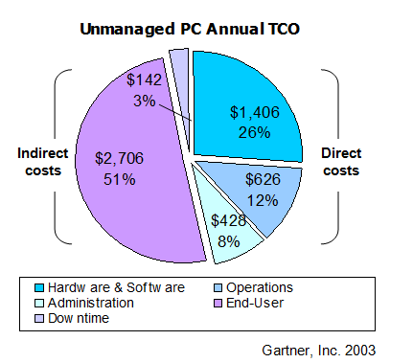
Timeline
Now we talk about the concept of timeline in an effective manner without any complication. The term deliverable may be intangible or tangible for any types of project. Various members of project’s team developed the timeline for any project efficiently without any types of complication. This is also known as a measurable outcome for any project. Under intangible criteria, the proper outcome is achieved by the team member those making a y project in an effective manner such as increment of turnover ratios for any company or organization. Tangible criteria determine various types of objects developed by various member of the team such as software’s components & reports of any types of software.
Now we determine different detailed task required for complete deliverable tasks. These tasks define as a selection of project, planning of project, execution & rollout of project, control & monitoring of various types of projects which are also very important for any types of project in an efficient manner. The last task is the end of any project in an efficient manner. Now we determine the duration for various tasks that we described previously in an effective manner. These tasks are a selection of project, planning of project, execution & rollout of project, control & monitoring of various types of projects which are also very important for any types of project in an efficient manner. Now we talk about the concept of duration of various tasks.
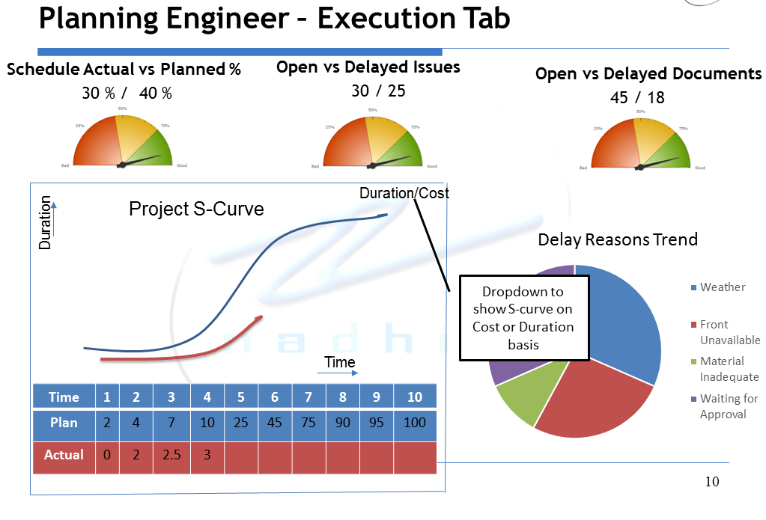

Project Timeline

Task/ Subtask | Responsible | Cost (US $ ‘000’) | Month 1 |  |  |  | Month 2 |  |  |  | Month 3
Task/ Subtask | Responsible | Cost (US $ ‘000’) | w1 | w2 | w3 | w4 | w1 | w2 | w3 | w4 | w1 | w2 | w3 | w4
Employee management system | P. Manager | 566
Requirement/Gathering | P. Manager | 250
Define scope | P. Manager | 25
Define goal | P. Team | 45
System Design | P. Team | 100
Interface design | P. Team | 50
Software/ Hardware Installation | P. Manager | 280
Testing | P. Team | 40
Usability testing | P. Manager | 160
Unit testing | P. Team | 55
Functionality testing | P. Manager | 106
Deployment | P. Manager | 33
Host the website | P. Team | 47
Maintenance of the system | P. Team | 46

Security

To enhance the safety of the system, the access of information by employees will be limited to the information they require. For privacy purposes, all the users of the system must register first to access the information. The system administrator in the company will be responsible for registering users and controlling all the accounts.A secure transmission model will be used for communication. The system will have an administrator account that controls all the activities. The account will make use of strong password and username to avoid unauthorized access. Another security measure of the website is that it will be updated regularly and inspected to avoid any kind of attack. (Gohel, 2015).

Primary security risks and threats

Security vulnerabilities lethargic in an appropriated framework can be deliberately misused or, then again accidentally activated. The dangers of misuse or activating are just potential, furthermore, appear as an assault or a mishap. Effective end and covering of vulnerabilities furthermore, threats require cost-based hazard examination.
Vulnerabilities exist in equipment, systems, working frameworks, database frameworks, , and applications. New ones are being found each day. Data about distinguished vulnerabilities and dangers can be gotten from the outstanding security occurrence databases, or metabases.
Phishing tricks are false endeavors by cybercriminals to acquire private data. Phishing tricks regularly show up in the pretense of email messages intended to seem like they are from authentic sources. For instance, the message would endeavor to bait you into giving your own data by imagining that your bank or email specialist co-op is refreshing its site and that you should tap on the connection in the email to confirm your record data and secret word points of interest.

Spam in the security setting is essentially used to portray email spam — undesirable messages in your email inbox. Spam, or electronic garbage mail, is an irritation as it can mess your letter box and in addition possibly consume up room on your mail server. Undesirable garbage mail promoting things you couldn't care less for is innocuous, generally. In any case, spam messages can contain joins that when tapped on could go to a site that introduces vindictive programming onto your PC.

Impacts on business

These security risks and threats impacts the business in wrong way, as they suffer with the loss of confidentiality, availability and integrity that can be separately assessed. Security risk or threats which are distinguished must be taken as an important aspect as in connection to the business condition and influence the business data. Risks act as an inseparable unit with vulnerabilities and in a comparable way these can be evaluated, measured regarding stimulation and ability. For case, the internal non-specialized staff in organization may have low experience to accomplish incredible noxious; because of their level to access the data for specific framework they work in abnormal state network. A programmer would have a high knowledge for pernicious aim and could have an unusual state of capacity to damage or interfere with the business. It is described that knowledge is not influenced in regular occurrence wonders. A low appraise is provided where the threat has practically zero capacity or knowledge. A high appraisal is done for those threats that are profoundly competent and unusually inspired (Welsh, 2005).

Analysis of threat for execution of plan
The end task is to survey the current policies, strategies and protection objects for satisfaction. In the case where there is no sufficient protection is given for desired policies, it can be accepted that there lies some vulnerabilities. An examination is done for existing and arranged protections should perform to decide whether the already known and found risks and threats have been moderated. It is not the occupation of the examiner to figure out what an adequate hazard is to an association. The investigator's part is to operate the protections from the defenselessness and hazard evaluation to help with deciding, alongside the gatherings included, what level of risk adequate to the association. The product is the reason for choosing fitting safety measure to be set up for those that are incapable. Over-protection can indicate superfluous expenses and overhead. The level of insurance required and practical will be assorted for every association. Conditions depend upon the extent of IT division they will most likely be not capable to maintain up the suggested shields. This will be used into account keeping in mind the end goal to adequately prescribe an item or system.
An association's system and security design assumes a huge part in how organize protectors and dangers work. Having a total comprehension of an association's system and security engineering because of their specific working model will encourage the plan and usage of security controls and help examiners in distinguishing identification focuses for risk perception. Experts should separate working frameworks into three classes to survey their affect on the operational condition. Those three classifications are servers, workstations, furthermore, cell phones. Portray the level of fixing and support on those, regardless of whether they are midway overseen by the business or not, what - if any - key hubs/data utilize a specific OS, and how dangers see each working framework (Kime, 2016).

Final analysis and recommendation

Good project management skills in the company will lead to successful implementation of the project. Successful implementation will result to numerous benefits. The project will increase the productivity of employees because they will not spend time moving to get information from their supervisors. Since all the information will be provided in the system, it will only require them to use the computers near their workstations to acquire the required information. All the expenses used in producing documents with instructions to employees can be directed to other activities in the company
Apart from the financial benefits of the company, this project will increase transparency and win the support from the internal and external stakeholders. All the employees in the same level will get access to the information concerning their responsibilities and achievements in the company. Management practices use different communication approaches, and some of the employees are left in the dark on issues affecting them (Kerzner, 2013). With this technology, the company will ensure uniform and timely access to documents and a fair evaluation process. Another benefit of this project is that central data storage enhances the communication between different departments in the company.

References

Badgujar, J., Jailia, M., & Kumar, A. (2015, March). Performance metrics of web crawler in client-server and MVC architecture. In Computer Engineering and Applications (ICACEA), 2015 International Conference on Advances in(pp. 393-398). IEEE.
Gohel, H. (2015). Design and development of combined algorithm computing technique to enhance web security. International Journal of Innovative and Emerging Research in Engineering (IJIERE), 2(1), 76-79.
Kerzner, H. (2013). Project management: a systems approach to planning, scheduling, and controlling. John Wiley & Sons.
Klastorin, T., & Mitchell, G. (2013). Optimal project planning under the threat of a disruptive event. IIE Transactions, 45(1), 68-80.
Tasevska, F., Damij, T., & Damij, N. (2014). Project planning practices based on enterprise resource planning systems in small and medium enterprises—A case study from the Republic of Macedonia. International journal of project management, 32(3), 529-539.

